Feedback Negative

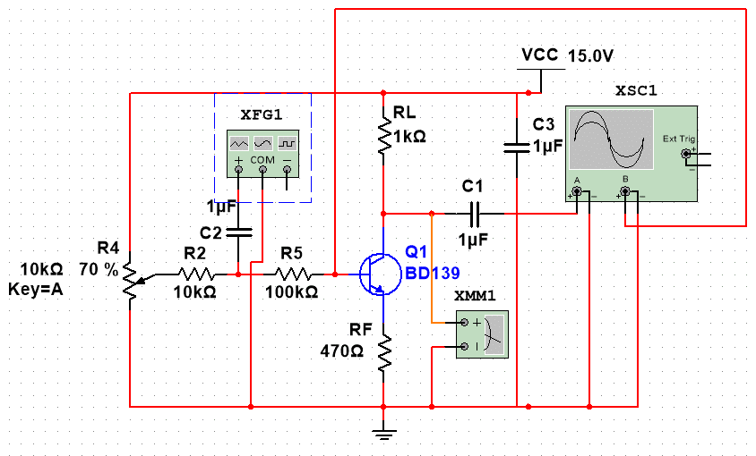

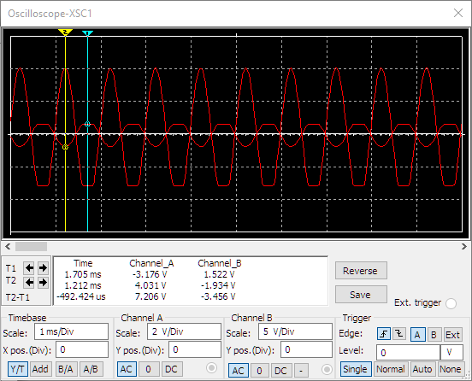

RF/RL = 470/1000 = 0.47

V Y1 (keluaran) = 7,206V | V Y2 (masukan) = 3,456V

Gain = 7,206V/3,456V = 2,085069 = 2,09

Feedback Negative

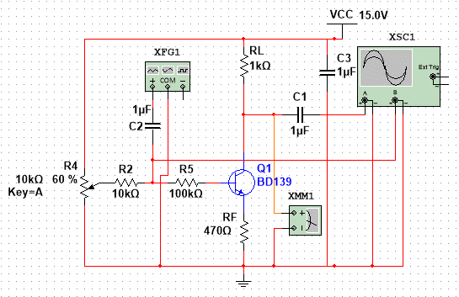

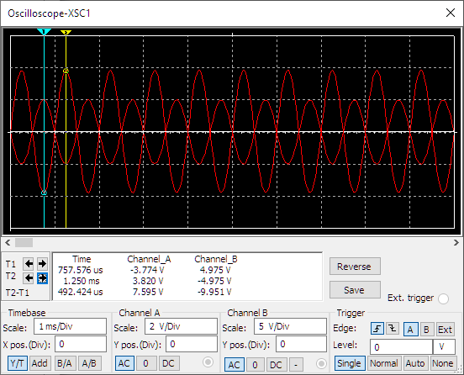

V(A) = 9,951V, V(B) = 7,595V

R(in) = V(B)/(V(A)-V(B)) = 7,595/(9,951-7,595) = 523,9kOhm